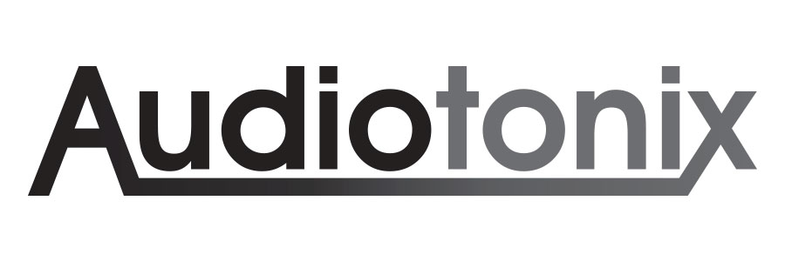
Environmental Policy
The Audiotonix Group and its Board of Directors recognises the importance of environmental governance and, whilst complying with all environmental legislation, regulations and appropriate codes of practice, seek continuous ways of minimising the impact our business activities have in the local and worldwide communities we operate within. As the designer and manufacturer of electronic products, our environmentally conscious design philosophy has been developed to encourage the use of recycled materials in new product design and, wherever possible, that the supply chain is local to our business operations to encourage minimal transport and packing waste.
Audiotonix actively encourages our R&D teams to be mindful of Environmentally Conscious Design best practices during the process of concepting, developing and supporting our products. As part of this good design practice the weight, size and material use will be reviewed to minimise the carbon footprint required to move the product around the globe. The development teams work with best in class suppliers to use environmentally responsible processes and recyclable materials wherever possible, and we are continually searching for new technologies and materials that offer opportunities to improve this further. Throughout the development of the new products, regular reviews are carried out to ensure we are meeting our goals of eco-design. These benchmarks are documented within our Audiotonix Environmentally Conscious Design Strategy that forms an integral part of the R&D design methodology. Since this introduction we have seen a number of initiatives driven by the R&D teams themselves which illustrate their drive and desire to improve the environmental footprint of the Groups products.
Key environmental impacts from Group operations relate to our energy and water consumption, waste generation and logistics. We are committed to minimising the potential environmental impacts from our operations by adapting the following principles:
• Quantify and monitor the significant environmental impacts of our activities
• Integrate environmental objectives into our business decisions
• Enhance awareness of good environmental practises amongst our staff and suppliers
• Emit plastic and non-recyclable consumables in our offices and factories
• Reduce and recycle as much waste as possible
• Reduce the consumption of electricity, gas and water in our buildings
• Strive to use green energy sources in our facilities
Energy management within each of our properties is key. We have introduced local monitoring to foster energy reduction through continuous building improvements and, in addition, we are migrating to renewable electrical energy and carbon neutral natural gas. In our business processes, we are introducing new IT technologies that will drastically reduce paper usage in our daily operations.
It is the policy of the Audiotonix Group to report from April 2020 publicly on its Environmental objectives and performances on an annual basis.
Approved on behalf of Audiotonix Group Limited by:

Tony Williams
Group Operations Director
October 2019

